Name:
Period:

AP Government – Unit 5 (Ch. 12) Study Guide
15-20% of course material and May 13, 2014 AP Exam
Mastery Questions, Hippocampus, and Practice FRQs
Due on Tues, February 11, 2014

Regarding Unit 5 material, from College Board:

Students must become familiar with the organization and powers, both formal and informal, of the major political institutions in the United States, including Congress. Students should understand that the policymaking institutions are separate institutions sharing powers and the implications of that arrangement. The functions these institutions perform and do not perform, as well as the powers that they do and do not possess, are important. It is necessary for students to understand that power balances and relationships between these institutions may evolve gradually or change dramatically as a result of crises. Students are also expected to understand ties between the various branches of national government and political parties, interest groups, the media, and state and local governments.”

Pinnacle Objectives for Unit 5:

IV. A. 1. Analyze the organizational structure of Congress, including its caucuses and committees.
IV. A. 2. Evaluate the various philosophies of representation held by congresspersons.
IV. A. 3. Explain the process of creating legislation.
IV. A. 4. Analyze the role of iron triangles and issue networks (subnational governments).
V. A. 1. Investigate policy making in a federal system.
V. A. 3. Explain the role of institutions in the enactment of policy.

Crash Course Correlations:
Ch. 10 and 14

Ch. 12: Congress - Mastery Questions
Crash Course Correlation: Ch. 10

1. Compare and contrast the two houses of our bicameral federal legislature.

2. List the formal powers of Congress found in Article 1, Section 8 of the Constitution. Underline those that are domestic powers. Highlight those that are foreign powers.
-
-
-
-
-
-
-
-
-
-
-
-
-
-
-
-
-
-
3. What are the informal (not in the Constitution nor tied to Constitution’s elastic clause) powers of Congress?
4. Explain congressional elections: How often do they occur? How much do they cost? What role do PACs play?

5. How often do members of the House get re-elected?
And the Senate?

6. What are the reasons for this incumbency advantage? In other words, what can incumbents do or use that works in their favor during a re-election campaign? (Use key terms!)
-
-
-
-
-
-
-

7. Explain the key leadership positions in the House and the Senate.
House of Representatives | Senate

8. List and explain the various types of committees that exist in the legislative branch. Provide examples for each. Highlight or underline specific committees that exist only in the House or Senate.
Type of Committee | Explanation of their purpose | Examples
9. What role do congressional caucuses play in legislative policymaking? Provide some examples of existing caucuses.

10. Diagram the process by which a bill becomes a law. Label the points in the process during which there are checks and balances in action.

11. What are the various factors that influence a congressional representative’s decision-making in voting on a bill?
-
-
-
-
-
12. Following the census, congressional districts for the House of Reps are reapportioned among the states. What does this mean? How does this affect our representation?

13. Consequently, after House seats are reapportioned, redistricting of the states needs to occur. What does this mean? How does this affect our representation?

14. What are the differences between “packing” and “cracking”? Diagram what each looks like.

15. Explain the major court case decisions regarding House of Reps districts.
Baker v. Carr
Wesberry v. Sanders

16. Terms lengths, term limits, congressional terms, and sessions….
What is the term length for members of Congress?
Why doesn’t Congress have term limits?
What would it take to impose term limits on Congress?
How often does a new term of Congress begin?
How often is Congress in session?
What does it take to convene Congress?
What does it take to adjourn Congress?

17. Define legislative veto. Explain the impact of INS v. Chadha on the legislature’s ability to use legislative veto.

Ch. 12 Hippocampus
Composition of the House
Committees and the Iron Triangle
Composition of the Senate
Power, Committees, and Debates
Route of a Bill through Congress
Veto Power and Judicial Review

Ch. 12 FRQs

2012 #1

Members of Congress are charged with three primary duties—writing laws, overseeing the implementation of laws, and serving the needs of their constituents.
(a) Describe the role of each of the following in lawmaking.
- Senate filibuster
- House Rules Committee
- Conference committee
(b) Describe one method by which Congress exercises oversight of the federal bureaucracy.
(c) Explain how casework affects members’ attention to legislation.

2012 #2
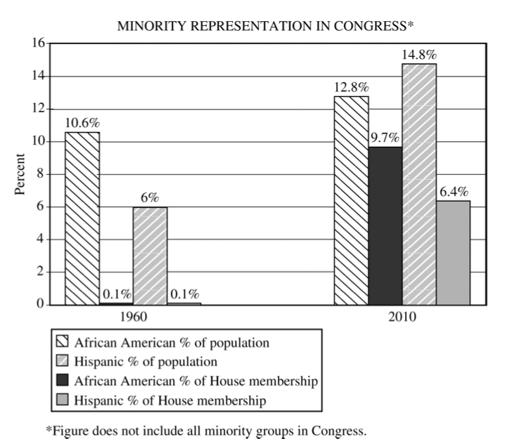

(a) Using the chart above, compare minority representation in 1960 and 2010.
(b) Explain how each of the following assisted in the removal of barriers to minority voting.
- Voting Rights Act of 1965
- Twenty-fourth Amendment
(c) Identify one barrier that currently impedes minority representation in Congress. Explain why the barrier
you identified inhibits minority representation in Congress.

2011 #2
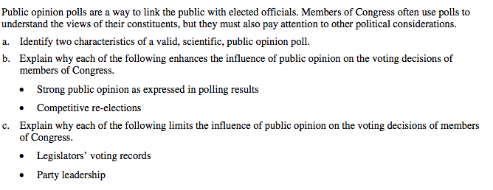

2011 #4
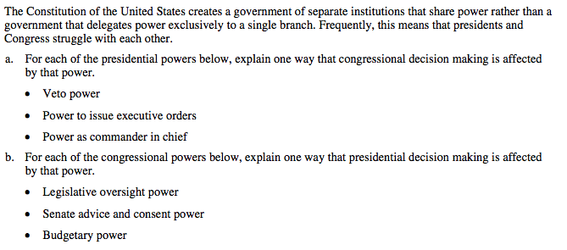

2010 #3
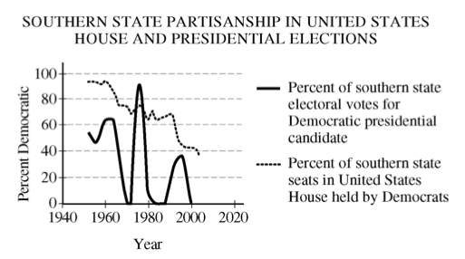

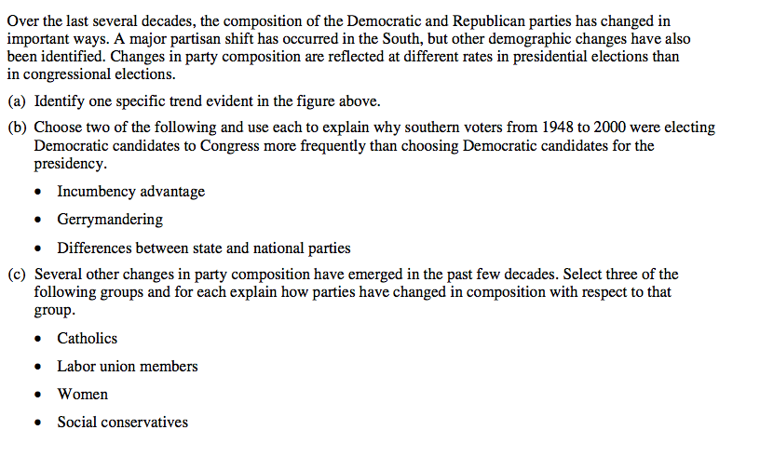

2009 #1
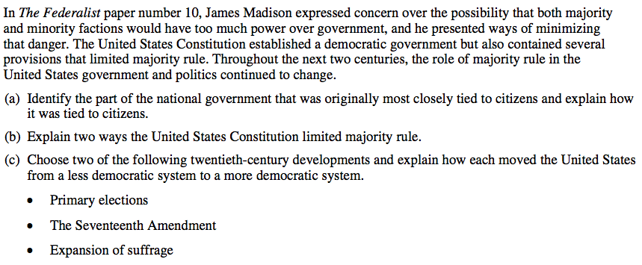

2009 #3
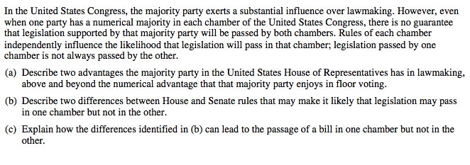

2008 #1
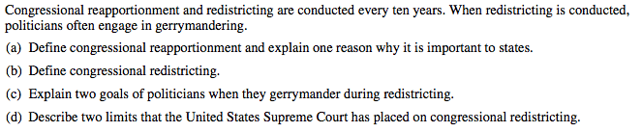

2007 #3
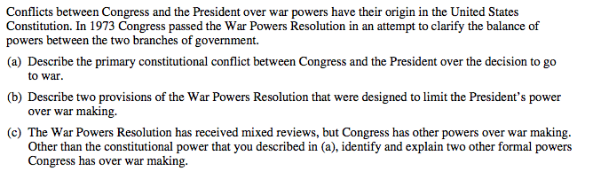

2006 #4
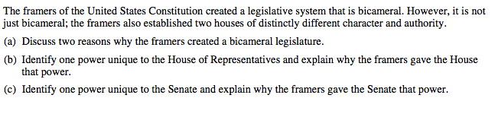

In emphasizing the importance of congressional committees, Woodrow Wilson once said, “Congress in session is Congress on display. Congress in committee is Congress at work.” Perform the following tasks regarding congressional standing committees:

- Describe two functions of congressional standing committees.
- Describe how congressional standing committees interact with each of the following:

- Interest groups
- Political parties
- The bureaucracy

